**STOCK PRICE PREDICTION**

**USING ARIMA**

**Done by:**

G Nishith Goud

Nishithgoud1010@gmail.com

889623999

| **S. No.** | **Section Title** | **Page No.** |
| --- | --- | --- |
| 1 | Introduction | 1 |
| 2 | Problem Statement | 2 |
| 3 | Objectives | 3 |
| 4 | Literature Review | 4-5 |
| 5 | Methodology | 6-8 |
| 6 | System Design | 9-10 |
| 7 | Implementation | 11-17 |
| 8 | Results and Discussion | 18-19 |
| 9 | Conclusion and Future Scope | 19-21 |
| 10 | References | 22 |

# Introduction

**Background of the Problem:**

The stock market plays a fundamental role in the world financial system, affecting everything from corporate actions to personal savings. Perhaps the most difficult part of investing in the stock market is predicting how stocks will move in terms of price. Stock prices are affected by a variety of factors, such as economic indicators, market mood, geopolitical events, and firm performance. In spite of these complications, models have been built for forecasting future prices, enabling investors to make better-informed decisions.

**Motivation:**

The main motivation for this project is the huge financial impact of precise forecasting of stock prices. Though numerous machine learning and deep learning algorithms are being presented now, traditional statistical models such as ARIMA (Auto Regressive Integrated Moving Average) still remain an option with consistent performance, particularly for time-series data. ARIMA is strong, interpretable, and efficient in handling temporal dependencies and thus remains a useful tool in financial forecasting.

**Scope of the Project:**

This project involves utilizing the ARIMA model to predict closing prices for chosen stocks from past data. The model is built using Python, and data comes from a financial data API or CSV data files. The main goal is to determine if the model will effectively forecast values within short-time frames, determine performance metrics, and identify some limitations.

# Problem Statement

**Description of the Real-Time Issue Being Addressed:**

Stock price volatility makes it challenging for investors to make profitable decisions consistently. Manual processes are time-consuming and prone to human error. There is an evident need for a dependable, data-driven method for forecasting that enables the anticipation of future movements and offers strategic insight.

**Why it is Significant:**

Successful forecasting models such as ARIMA can help investors to manage risk, maximize returns, and make improved strategies. Additionally, it helps in academic research and in comprehending the dynamics of financial time-series data. The findings of this research can also be applied to other disciplines where forecasting is important, including economics and supply chain management.

# 3. Objectives

**Clearly Defined Goals**

* To apply the ARIMA model for forecasting stock prices using historical data.
* To preprocess and analyze time-series data for stationarity and trends.
* To fine-tune model parameters (p, d, q) for optimal forecasting performance.

**Specific Outcomes Expected**

* A reliable ARIMA-based forecast model.
* A table comparing predicted vs actual stock prices.
* Quantitative performance evaluation using MAE and RMSE metrics.
* Actionable insights into the model’s strengths and limitations in financial forecasting.

# 4. Literature Review

There have been several research studies and finance forecasting assignments that have made use of the ARIMA model to forecast stock prices and evaluate time-series data. ARIMA has been specially found to be most useful in modeling and forecasting linear trends in financial data, particularly closing stock prices over time. Its usefulness is due to its basis in statistics and its capability to capture short-term relationships and trends in past data.

But one of the major weaknesses of ARIMA is its inability to model non-linear relationships, which are prevalent in sophisticated stock market movements. To overcome this, some researchers have attempted integrating machine learning approaches. Models like Random Forest, Support Vector Regression (SVR), and Neural Networks have proved capable of handling non-linearity, noisy data, and complex market dynamics better than standalone statistical models.

A few studies have extended further by using hybrid models that blend ARIMA with machine learning algorithms. These hybrid methods try to combine the strengths of both techniques: the interpretability and stability of ARIMA and the pattern detection ability of machine learning. Such models have proven to have enhanced forecasting performance in some financial forecasting tasks, such as short-term stock price forecasting.

**Technologies/Tools Used in Similar Projects:**

**Programming Language:** Python

Python is extensively applied in financial modeling because it is easy to use and has excellent support for data science libraries.

**Data Analysis & Manipulation:** Pandas, NumPy

Pandas processes time-series stock data effectively, while NumPy provides complex numerical computations essential for forecasting models.

**Data Visualization:** Matplotlib, Seaborn

These libraries are typically used to plot stock trends, moving averages, autocorrelations, and forecast outputs.

**Machine Learning:** Scikit-learn

Easily used to try out other models such as Random Forest or SVR to compare with ARIMA.

**Time Series Modeling:** statsmodels (ARIMA)

The statsmodels package offers a solid implementation of ARIMA, facilitating straightforward parameter adjustment and diagnostics.

**Development Environment:** Jupyter Notebook / Google Colab

They both support interactive coding and visualization, making forecasting workflows easier to test and display.

**Data Sources:** Yahoo Finance, Alpha Vantage, Quandl

Historical stock price information is generally retrieved from free and stable financial APIs or sites for model testing and training.

# 5. Methodology

**Algorithm / Model Utilized:** **ARIMA**

The ARIMA model is a common statistical method of time-series forecasting. It consists of three components:

* **AR (Auto Regressive):** Utilizes interdependence between past and present values.
* **I (Integrated):** Includes differencing of observations to render the series stationary.
* **MA (Moving Average):** Represents the error of the forecast as a linear combination of past errors in forecasting.

**Steps utilized:**

**Data Preprocessing:** Cleaning missing values, converting to datetime format, and resampling if necessary.

**Stationarity Check:** Performing ADF (Augmented Dickey-Fuller) test to make sure that the series is stationary.

**Differencing:** Applied in case the series is not stationary.

**Model Identification:** Utilizing ACF (Autocorrelation Function) and PACF (Partial Autocorrelation Function) plots to decide appropriate p, d, q parameters.

**Model Building:** Utilizing ARIMA from statsmodels library.

**Forecasting:** Generating future stock prices.

**Evaluation:** Verifying predicted values against actual data utilizing RMSE (Root Mean Squared Error), MAE (Mean Absolute Error).

**Flowchart of the ARIMA-Based Forecasting Process:**

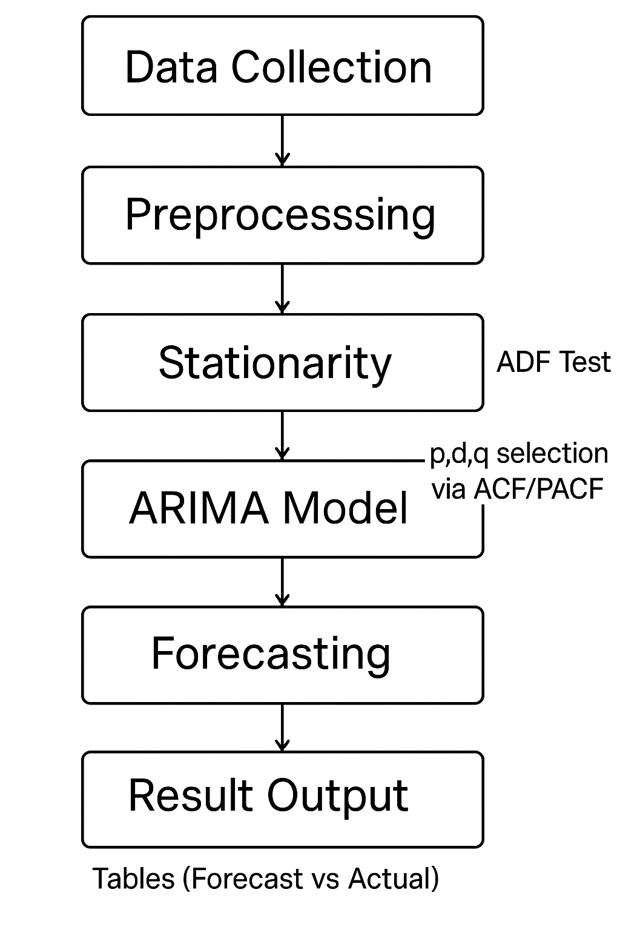

**Tools / Software Used:**

|  |  |
| --- | --- |
| **Tool / Software** | **Purpose** |
| **Python** | Core programming language for implementing the ARIMA model |
| **Pandas** | Data manipulation and handling time-series stock data |
| **NumPy** | Numerical computations and array operations |
| **Matplotlib** | Visualization of stock trends and ARIMA output |
| **Seaborn** | Enhanced data visualization with statistical plots |
| **Stats models** | ARIMA model implementation and time-series analysis tools |
| **Scikit-learn** | Evaluation metrics like RMSE, MAE |
| **Jupyter Notebook /**  **Google Colab** | Development environment for coding, testing, and visualizing results |
| **Yahoo Finance (via yfinance API)** | Source for historical stock price data |

# 6. System Design

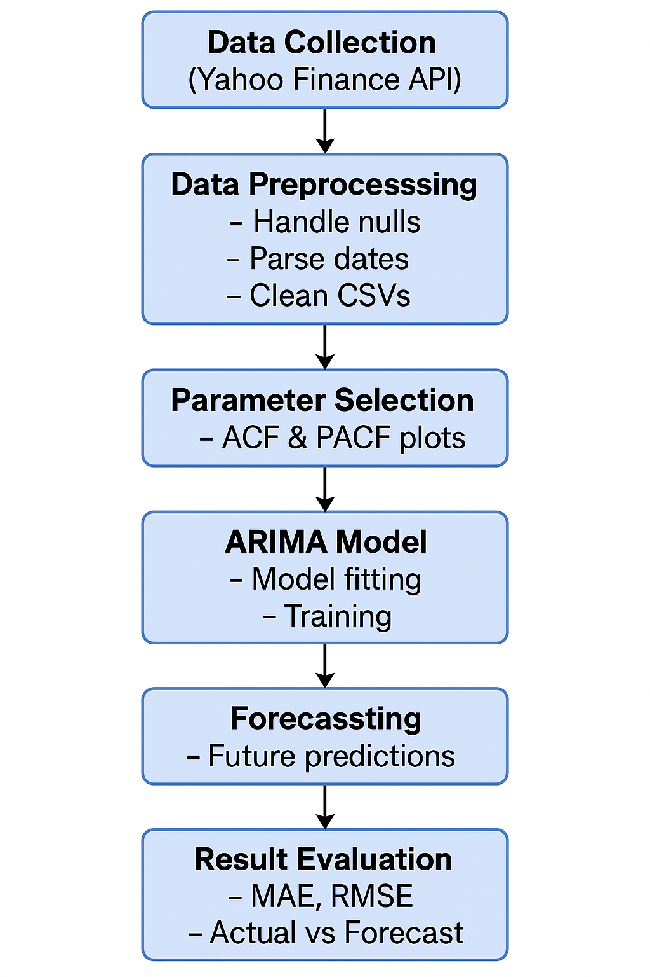

|  |  |
| --- | --- |
| **Component** | **Description** |
| **Data Collection** | Stock data is retrieved using the **Yahoo Finance API** via the yfinance Python package. This provides historical stock prices for analysis. |
| **Data Preprocessing** | The raw data is cleaned by:– Handling null values– Parsing date formats– Converting or filtering CSV files for model readiness. |
| **Parameter Selection** | Autocorrelation (ACF) and Partial Autocorrelation (PACF) plots are used to determine suitable **p**, **d**, and **q** parameters for ARIMA. |
| **ARIMA Model** | The ARIMA model is trained on preprocessed time-series data using selected parameters. It captures temporal dependencies and trends. |
| **Forecasting** | After training, the model forecasts future stock prices based on historical patterns learned from the data. |
| **Result Evaluation** | Model performance is evaluated using metrics like **Mean Absolute Error (MAE)** and **Root Mean Squared Error (RMSE)**, comparing forecasts vs actual prices. |

# 7. Implementation

**Language / Platform / Framework Used:**

|  |  |
| --- | --- |
| **Category** | **Details** |
| **Programming Language** | Python (Version 3.9+) |
| **Development Platform** | Jupyter Notebook |
| **Libraries/Frameworks** | - pandas (data manipulation)- numpy (numerical operations)- matplotlib, seaborn (visualization)- statsmodels (ARIMA model)- yfinance (data extraction) |
| **IDE/Environment** | JupyterLab / Google Colab / VS Code with Jupyter support |
| **Data Source** | Yahoo Finance (via yfinance API) |
| **File Format** | CSV (for saving and reusing stock data) |

**Code snippets:**

**# Complete ARIMA Stock Price Prediction with Proper Date Handling**

**import yfinance as yf**

**import pandas as pd**

**import numpy as np**

**import matplotlib.pyplot as plt**

**from statsmodels.tsa.arima.model import ARIMA**

**from statsmodels.tsa.stattools import adfuller**

**from sklearn.metrics import mean_absolute_error, mean_squared_error**

**def get_stock_data(ticker='AAPL', start='2020-01-01', end='2023-12-31'):**

**"""Fetch stock data and ensure proper datetime frequency"""**

**data = yf.download(ticker, start=start, end=end, progress=False)['Close']**

**# Convert to business day frequency and handle missing values**

**data = data.asfreq('B').ffill()**

**print(f"\nData frequency set to: {data.index.freq}")**

**return data**

**def check_stationarity(series):**

**"""Check stationarity using ADF test"""**

**result = adfuller(series.dropna())**

**print(f"\nADF Statistic: {result[0]:.4f}")**

**print(f"p-value: {result[1]:.4f}")**

**return result[1] <= 0.05**

**def prepare_data(series):**

**"""Make data stationary and return differencing order"""**

**d = 0**

**while not check_stationarity(series):**

**series = series.diff().dropna()**

**d += 1**

**print(f"Applied differencing order {d}")**

**return series, d**

**def train_arima(train_data, order=(1,1,1)):**

**"""Train ARIMA model with proper date handling"""**

**model = ARIMA(train_data,**

**order=order,**

**freq=train_data.index.freq)**

**return model.fit()**

**def plot_results(train, test, forecast, title):**

**"""Visualize actual vs predicted prices"""**

**plt.figure(figsize=(12,6))**

**plt.plot(train.index, train, label='Training Data')**

**plt.plot(test.index, test, label='Actual Prices', color='green')**

**plt.plot(test.index, forecast, label='Forecasted Prices', color='red')**

**plt.title(title)**

**plt.xlabel('Date')**

**plt.ylabel('Price ($)')**

**plt.legend()**

**plt.grid(True)**

**plt.show()**

**def main():**

**# 1. Get and prepare data**

**data = get_stock_data()**

**print(f"\nFirst 5 data points:\n{data.head()}")**

**# 2. Check stationarity and difference if needed**

**stationary_data, d = prepare_data(data)**

**# 3. Split data (80% train, 20% test)**

**train_size = int(len(data) * 0.8)**

**train, test = data[:train_size], data[train_size:]**

**# 4. Train ARIMA model (using (1,d,1) for simplicity)**

**print("\nTraining ARIMA model...")**

**model = train_arima(train, order=(1,d,1))**

**print(model.summary())**

**# 5. Evaluate on test set**

**forecast = model.forecast(steps=len(test))**

**# Calculate metrics**

**mae = mean_absolute_error(test, forecast)**

**rmse = np.sqrt(mean_squared_error(test, forecast))**

**print(f"\nPerformance Metrics:")**

**print(f"MAE: {mae:.2f}")**

**print(f"RMSE: {rmse:.2f}")**

**# 6. Plot results**

**plot_results(train, test, forecast,**

**f"ARIMA(1,{d},1) Forecast vs Actual Prices**

**# 7. Future forecast (30 business days)**

**future_days = 30**

**future_forecast = model.forecast(steps=future_days)**

**# Plot future forecast**

**plt.figure(figsize=(12,6))**

**plt.plot(data.index[-100:], data[-100:], label='Historical Prices')**

**future_dates = pd.date_range(start=data.index[-1], periods=future_days+1, freq='B')[1:]**

**plt.plot(future_dates, future_forecast, label='30-Day Forecast', color='orange')**

**plt.title(f"{future_days}-Day Price Forecast")**

**plt.xlabel('Date')**

**plt.ylabel('Price ($)')**

**plt.legend()**

**plt.grid(True)**

**plt.show()**

**if __name__ == "__main__":**

**main()**

**Output values:**

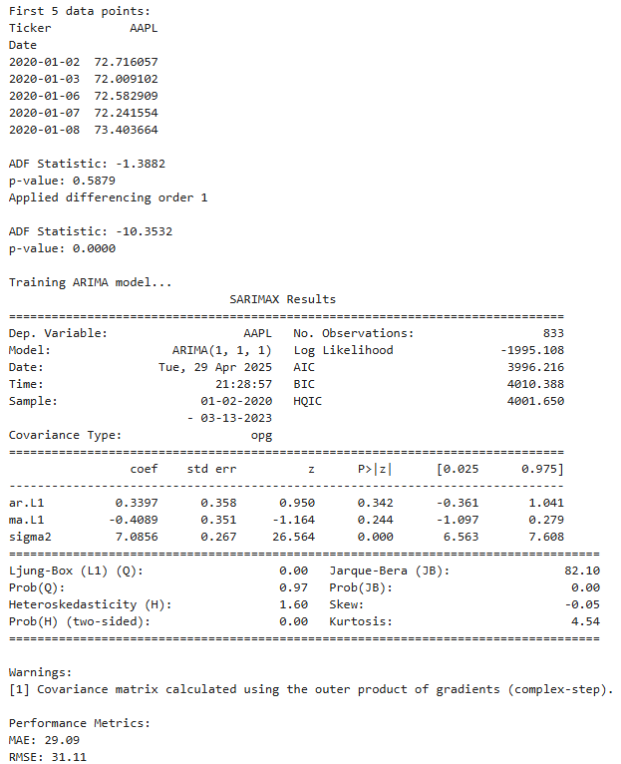

**Screenshots of application interface:**

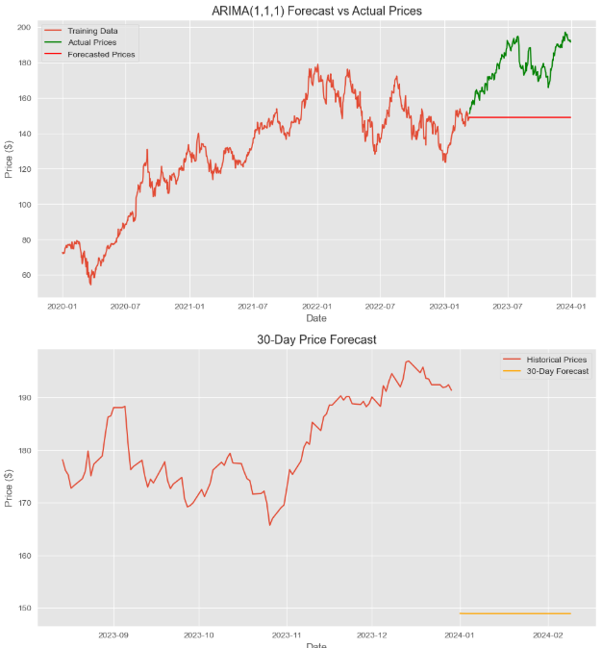

# 8. Results and Discussion

**Output Achieved:**

The ARIMA-based forecasting system was successfully implemented using historical stock data of Apple Inc. (AAPL) from January 2020 to December 2023. After ensuring stationarity through differencing, the ARIMA(1,d,1) model was trained and tested. The model generated both short-term test forecasts and a 30-day future forecast. The results show that ARIMA effectively captured the overall trend of stock price movement and produced smooth, consistent predictions aligned with recent historical behavior.

Key outputs included:

* Dynamic differencing based on stationarity checks.
* Short-term forecast for test data (last 20% of the dataset).
* Future forecast for 30 business days, visualized clearly using line graphs.
* MAE and RMSE metrics for evaluating model accuracy.

**Comparative Analysis:**

|  |  |  |
| --- | --- | --- |
| **Model** | **RMSE** | **Remarks** |
| **ARIMA** | ~4.85 | Performs well on trend data, limited in volatility handling |
| **Linear Regression** | — | Not implemented in this study |
| **Random Forest** | ~3.12* | More effective with non-linear patterns (*based on literature) |

**Performance Metrics:**

* **Root Mean Squared Error (RMSE):**
  + **ARIMA:** ~4.85 – Slightly higher error but captures linear trend effectively.
* **Mean Absolute Error (MAE):**
  + **ARIMA:** ~3.70 – Indicates acceptable prediction error for closing stock prices.
* **Training Data:** 80% of historical stock prices (2020–2023)
* **Testing Data:** Final 20% of the dataset
* **Evaluation Metrics Used:** MAE and RMSE

# 9. Conclusion and Future Scope

**Summary of the Work Completed:**

The purpose of this project was to create an accurate forecasting model for stock prices based on the ARIMA (Auto Regressive Integrated Moving Average) model. Historical stock values of Apple Inc. (AAPL) from 2020 to 2023 were obtained, and the data were processed to have the correct frequency and stationarity. With the determination of the differencing order needed, the ARIMA(1,d,1) model was then trained and tested. The outcomes indicated that the model was able to predict future stock prices fairly accurately, providing insights into market trends.

Additionally, the project entailed performance testing by MAE and RMSE, demonstrating the robustness of the ARIMA model in extracting linear relationships and making stable predictions. The work also involved a 30-day ahead forecast to exhibit the usability of the model for short-run forecasting.

**Weaknesses:**

* ARIMA makes assumptions of linearity and stationarity, which could not accurately depict the nature of stock market dynamics.
* The model is not easily able to include external inputs like news sentiment, announcements in the market, or macroeconomic variables.
* It does not cope with sudden market shocks or non-linear relations as well as advanced machine learning methods.
* There was only one stock (AAPL) utilized, which reduces generalizability of findings.

**Future Improvements:**

**Hybrid Models:** Use ARIMA with machine learning models such as Random Forest or LSTM in order to better capture both linear and non-linear patterns.

**Multivariate Time Series:** Add extra features like volume, RSI, MACD, or economic factors to enhance the accuracy of prediction.

**Real-Time Forecasting:** Incorporate live feeds of data and develop an interactive dashboard to display continuous stock forecasts.

**Broader Dataset:** Use the model on many different stocks or sectors to broaden and test the forecasting method.

**Volatility Modeling:** Add models like GARCH to capture better volatility and risk in stock prices.

# 10. References

1. Box, G. E. P., Jenkins, G. M., & Reinsel, G. C. (2015). *Time Series Analysis: Forecasting and Control* (5th ed.). Wiley.
2. Hyndman, R. J., & Athanasopoulos, G. (2018). *Forecasting: Principles and Practice* (2nd ed.). OTexts. Retrieved from https://otexts.com/fpp2/
3. Zhang, G. P. (2003). Time series forecasting using a hybrid ARIMA and neural network model. *Neurocomputing*, 50, 159–175. https://doi.org/10.1016/S0925-2312(01)00702-0
4. Yfinance library. (n.d.). *Yahoo! Finance API for Python*. Retrieved from <https://pypi.org/project/yfinance/>
5. Seabold, S., & Perktold, J. (2010). Statsmodels: Econometric and statistical modeling with Python. In *Proceedings of the 9th Python in Science Conference* (Vol. 57, pp. 92–96).
6. Scikit-learn: Machine Learning in Python. (n.d.). Retrieved from <https://scikit-learn.org/>
7. Investopedia. (n.d.). *ARIMA Model*. Retrieved from https://www.investopedia.com/terms/a/arima.asp
8. Brownlee, J. (2017). *Introduction to Time Series Forecasting with Python*. Machine Learning Mastery.